# GitLab Branching and Merging Lab

## · Explain branching and merging

**Branching:**  
Branching in Git allows developers to create separate lines of development. A branch is a pointer to a specific commit, enabling independent work on features, bug fixes, or experiments. It provides isolation from the main codebase.  
  
**Merging:**  
Merging is the process of bringing changes from one branch into another. It combines the commit history and code content. If the same lines are changed in both branches, a merge conflict might occur and needs to be resolved manually.

## · Explain about creating a branch request in GitLab

In GitLab, a 'branch request' usually refers to creating a new branch to begin work on a feature or issue. This branch is pushed to the GitLab remote repository and signals the start of work. This is typically done using Git CLI or GitLab's web interface.

## · Explain about creating a merge request in GitLab

A Merge Request (MR) in GitLab is a formal way to propose merging code from one branch into another. It includes a description, reviewers, and often links to related issues. After code review and approval, the MR is merged into the target branch.

# Git Bash Commands Executed

$ mkdir GitLabPractice

$ cd GitLabPractice

$ git init  
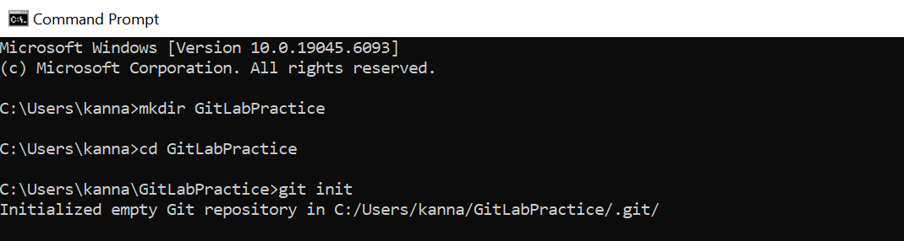

$ echo "Initial content" > main.txt

$ git add main.txt

$ git commit -m "Initial commit on master"

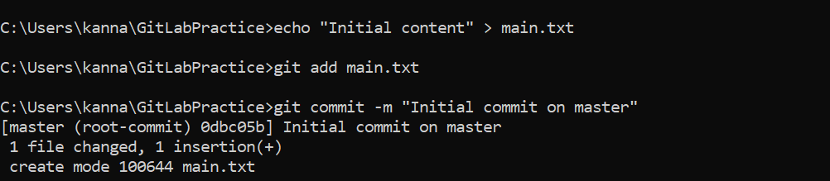

$ git config --global user.name "karnatisreejareddy9603"

$ git config --global user.email "sreejareddy9603@gmail.com"

$ git branch GitNewBranch  
  
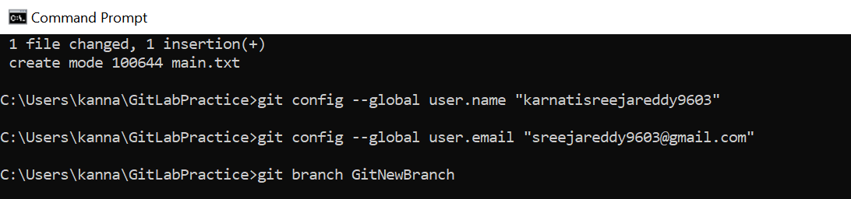

$ git branch -a  
$ git checkout GitNewBranch  
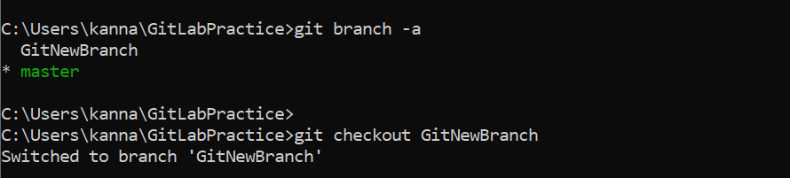

$ echo "This is a test file for GitNewBranch" > branchfile.txt  
$ git add branchfile.txt  
$ git commit -m "Added branchfile.txt in GitNewBranch"  
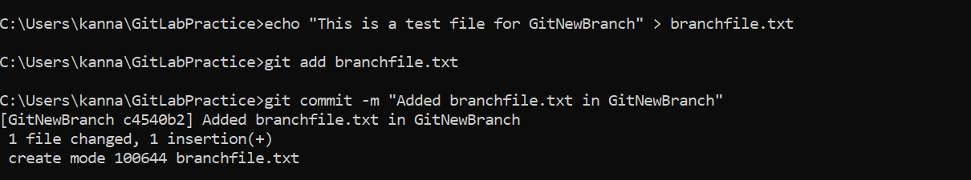

$ git status

$ git checkout master

$ git diff GitNewBranch

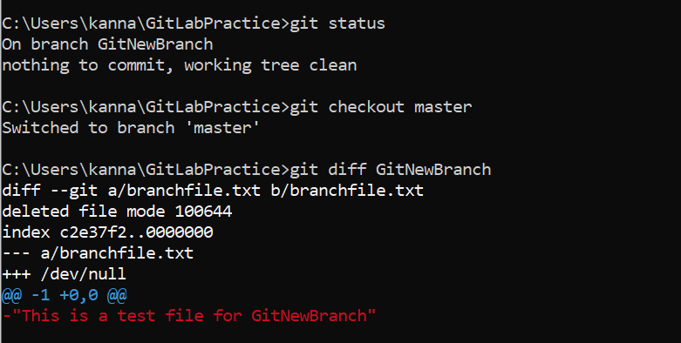

$ git difftool GitNewBranch

$ git config --global diff.tool p4merge

$ git config --global difftool.prompt false

$ git merge GitNewBranch

$ git log --oneline --graph --decorate  
  
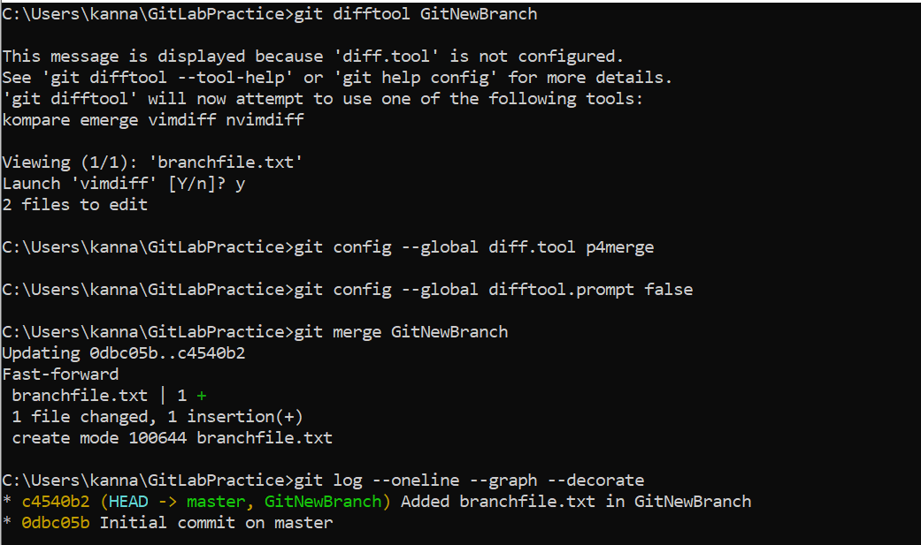

$ git branch -d GitNewBranch  
$ git status  
  
  
